CSI3660 / F2018 / Lab 2

Prof. Fredericks

**DUE DATE: Wednesday, September 26th at 11:59pm (via Moodle)**

**Overview**

This assignment has you installing Linux on your virtual machine, from scratch. This will give you experience not only in installing a non-Windows operating system, but in dealing with some of the headaches that come along with installing a server via VMWare. Note, you'll need to be on the school VPN to use the VMware client (a lab computer doesn't need VPN if you are having issues with that).

You will be required to submit a lab report, the details of which are at the bottom of this document. Also, keep your eye open for any notes in **BOLD AND RED**. This is also a requirement for you (and your grade).

**IMPORTANT NOTE**

Whatever you do. DO NOT SHUT DOWN THE MACHINE.

I repeat.

DO

NOT

SHUT

DOWN

YOUR

VIRTUAL

MACHINE

Don't shut it down by typing shutdown -h now.

Don't shut it down in vSphere.

Why?

If you shut it down, you cannot turn it back on.

Only I can turn it back on. And that means you’re going to have to wait until I am able to get to you to turn your machine back on.

This is a feature of vSphere.

If you need to cycle power, reboot (or reset) the machine.

But.

Do. not. shut. it. down.

**Lab Manual**

Each virtual machine on the server has Scientific Linux 7 loaded in its disc drive. We will be using this to install

the operating system. For this lab, we will be using the VMware vSphere web client to perform the installation

(http://vcenter6.secs.oakland.edu).

**CONFIGURATION AND SETUP**

1) First, login to the vSphere client (vcenter6.secs.oakland.edu) with your SECS account and then navigate to your virtual machine (vCenter Inventory Lists -> Virtual Machines). Right click on your virtual machine, and then click ‘Open Console.’

Note that this is a Flash application (or HTML5 if vSphere is updated). **You need to click in the window that you see in order for any keyboard commands to work!**

You should now see a screen asking you to login to Scientific Linux 7. This is the login screen for the Live CD (it is not installed – Linux is running off the virtual CD). If you do not see this, you need to get to this point.

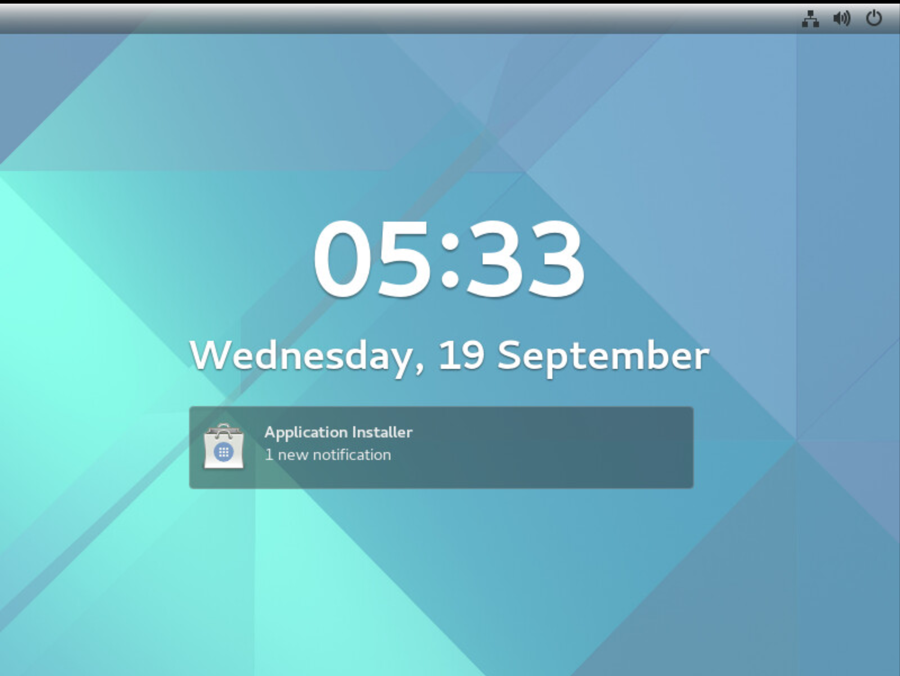

You may also see a screen like this:

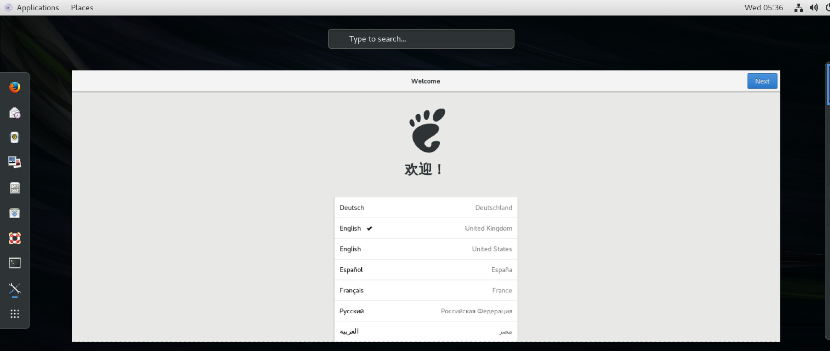

*Note, if either screen doesn’t come up you need to reboot.*

The first screen is waiting for you to 'swipe up.' Click and drag the mouse from the bottom up to get to a login screen. The second screen just go through the prompts.

2) You should see the Desktop. Again, this is the Live CD desktop. Nothing is installed yet.

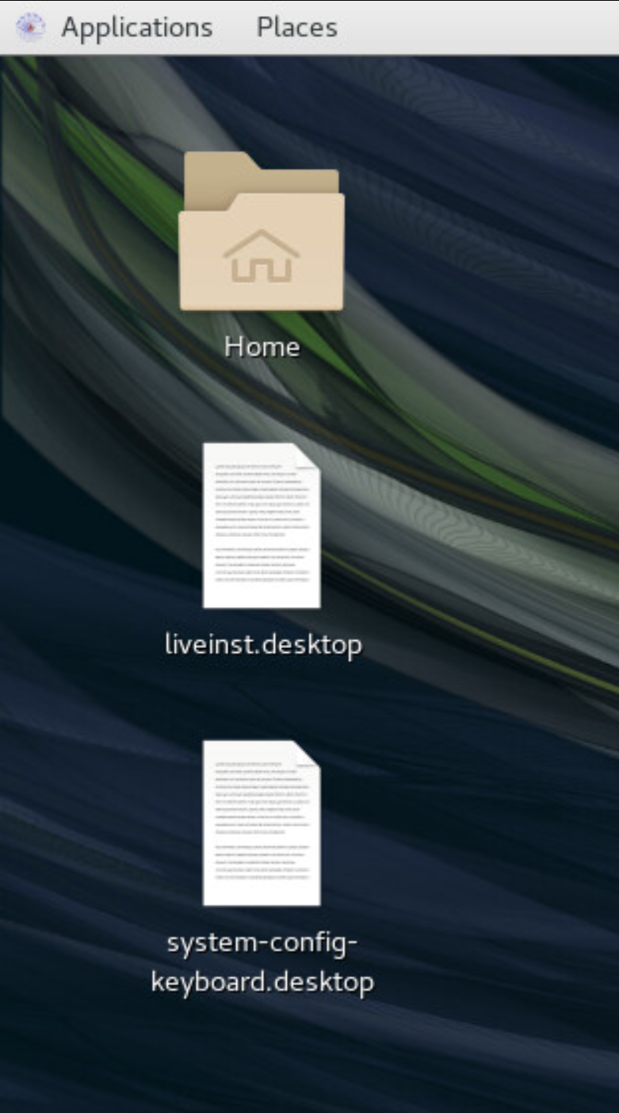

Double click on the liveinst.desktop file. You'll get a popup, click 'Trust and Launch.' This will kick off the installer. Follow along with the prompts until you get to this screen.

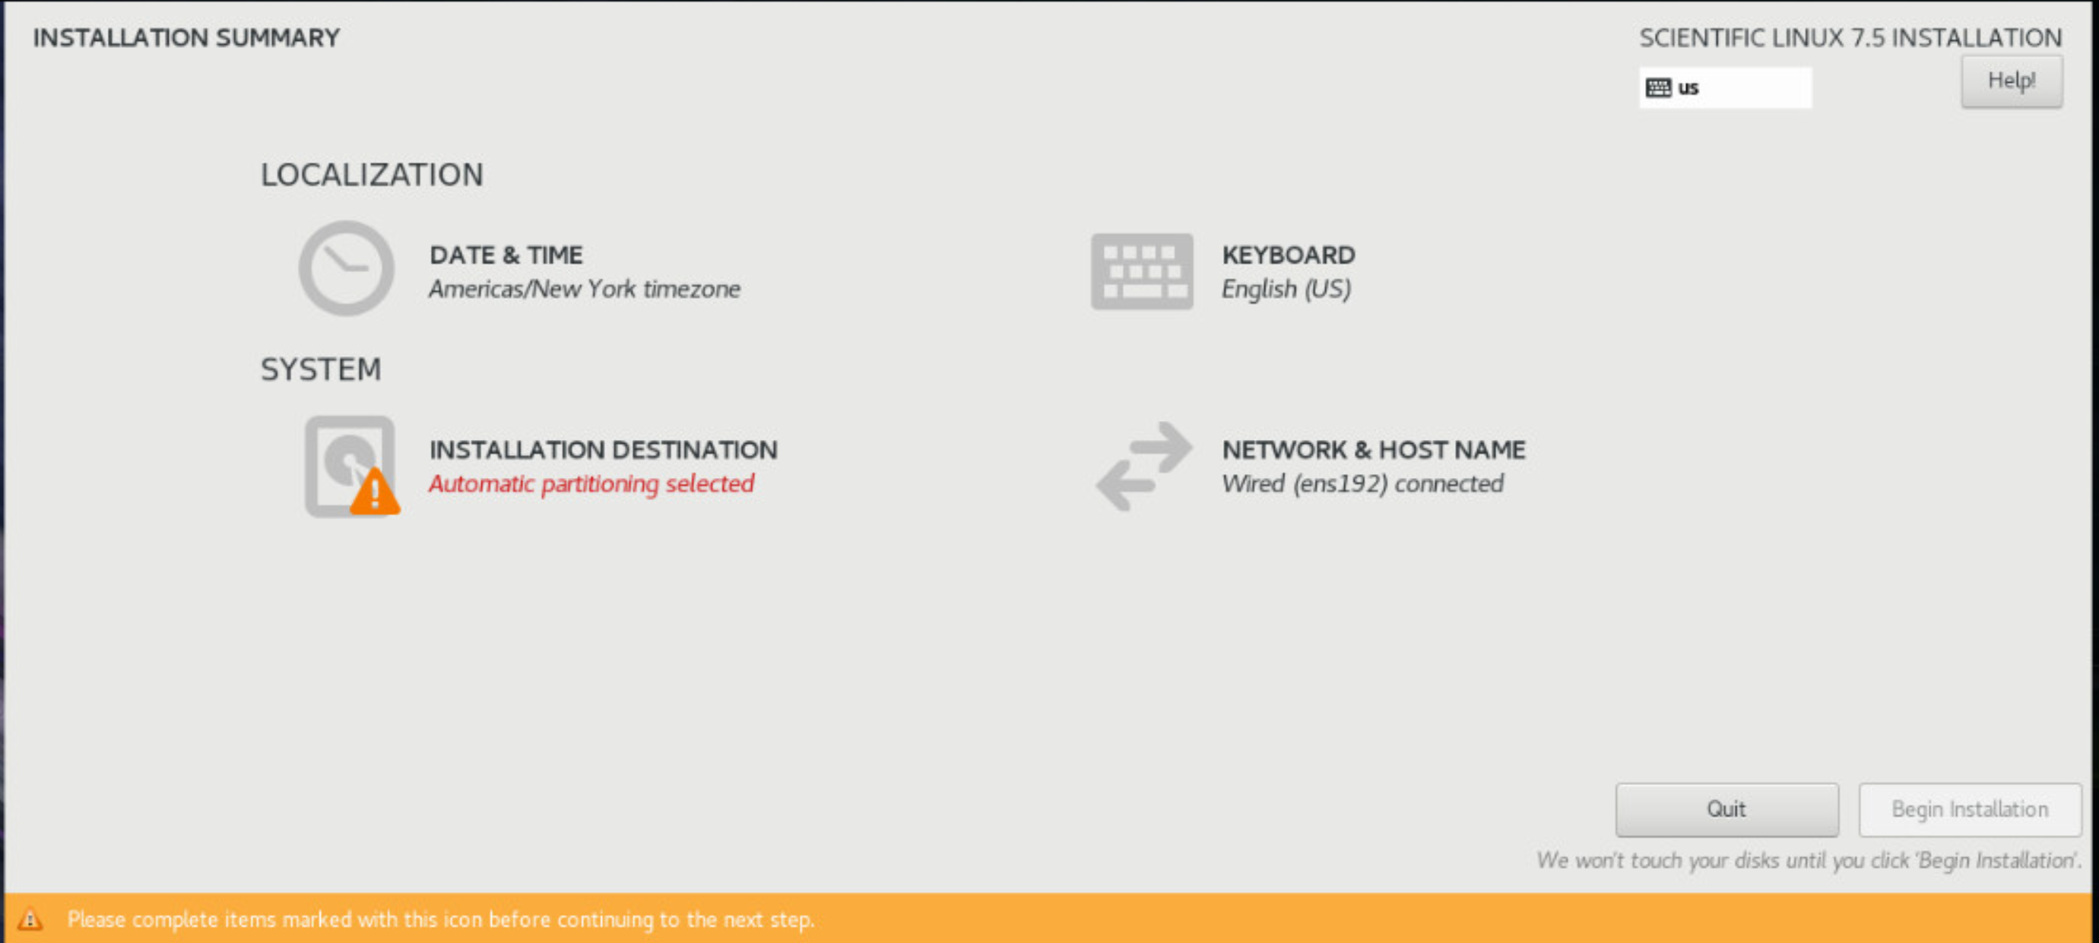

Now, click the icon that has the warning symbol (INSTALLATION DESTINATION). We're going to leave the default partitioning scheme, but here is where you could partition your hard drive if you wished. Click the hard drive (VMWare Virtual Disk) and then click Done in the top left corner. Then, click 'Begin Installation.'

3) It is time to set a root password and create your user.

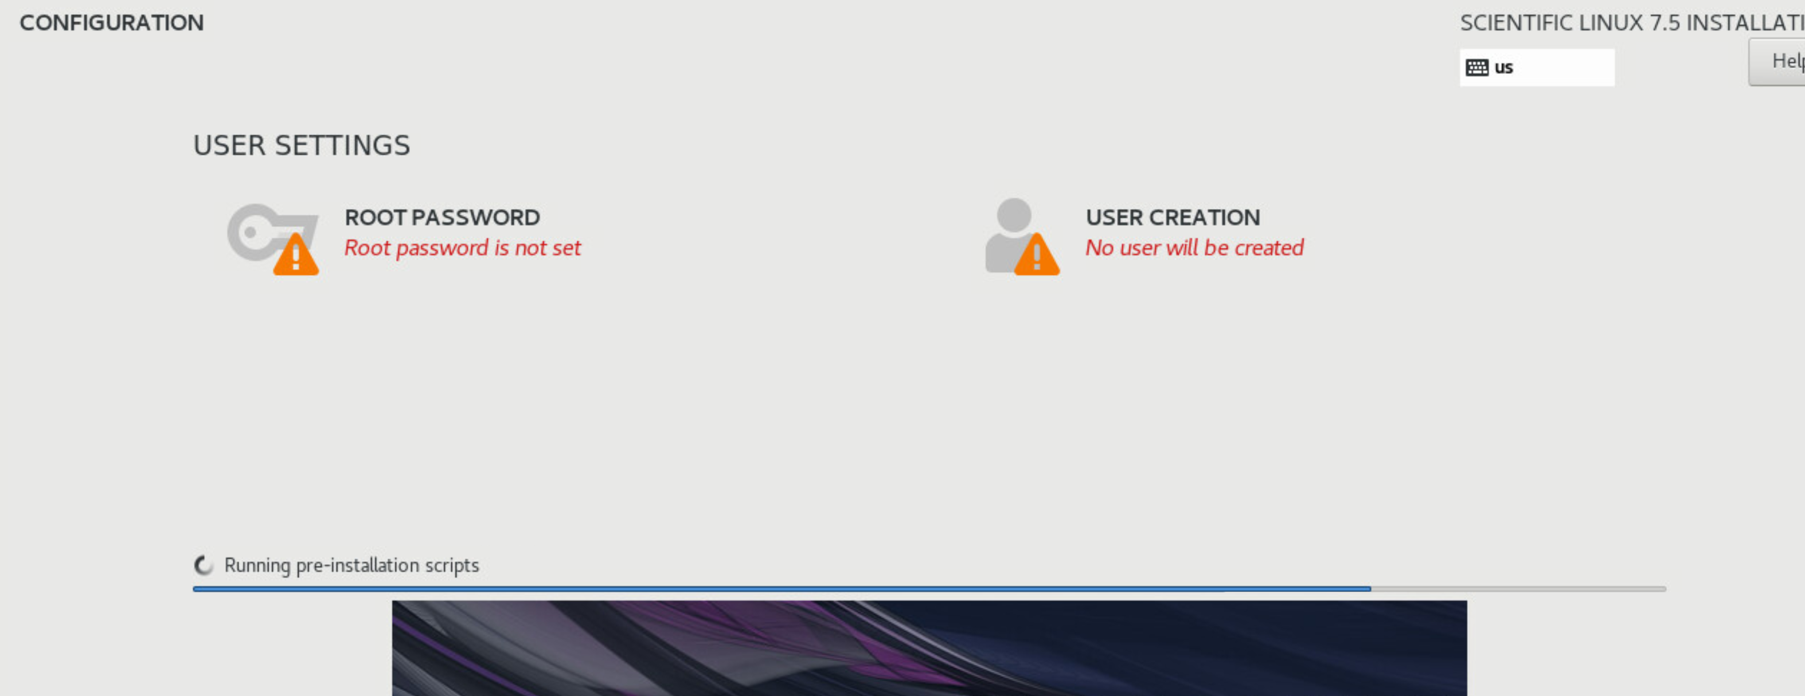

Click each of those icons. Set a root password to be something you will remember --- this is the superuser account. Create a user for yourself as well, giving yourself administrative privileges as you do so.

(Don’t change anything though, simply click Cancel).

7) Go ahead and reboot (power icon in the top right corner). It should automatically boot to the desktop. Accept the license configuration. Click the 'Network and Host Name' option and **take a screenshot and paste it into Question 2.**

8) Congratulations, you’ve performed a Scientific Linux 7 install!

Now it’s time to get this thing configured. You’ll need to create user accounts for myself and the TA. And a few other things. Like I said, this class will have a big practical focus.

First things first, we need to make this boot to the terminal instead of the graphical desktop.

Open up a terminal. Type in runlevel (you should see N 5).

Now run: $ sudo systemctl set-default multi-user.target

And then:

$ sudo reboot

If you’ve **never** logged into a Linux (or similar) machine without a graphical desktop, welcome to the world of servers. A place where we don’t need no graphics.

You should see something like this:

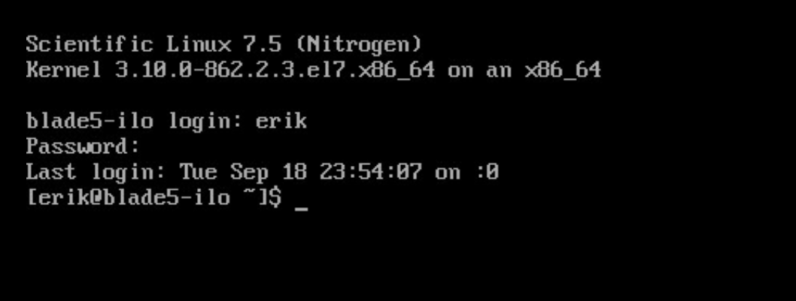

There are reasons for that, naturally. Not just nerd pride.

Login with your new username and password that you just created.

9) Type in groups and hit enter. You should see your username (your default group) and wheel. (If you don’t see wheel, then you didn’t make yourself an administrator). **What is the purpose of the wheel group? – write your answer in the lab report section**

10) Now, type ip a and hit enter. Make note of your IP address, as I will ask for it later. It should start with 141.210.25.

**IP address: ________________**

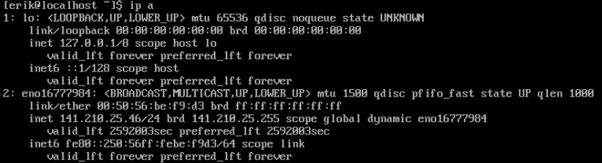

*Above is what my screen looks like. My IP address is 141.210.25.46 (we ignore the /24 for now)*

12) Create two new users: **fredericks** and **palagudi**. For each, set the password as **temp12345** and the group

as **wheel** for each user (you should be able to use sudo).

* The command to create a user is: useradd <user> (or adduser, one is an alias of the other).

* To set the password, either look at the man page for useradd or passwd for the appropriate configuration.

Keep in mind you will need elevated privileges to do so.

* Ensure that each user (yourself, myself, and your TA) are each in the wheel group. Use the groups <username> command.

* If you don’t set the wheel group upon user creation, you’ll want the usermod -aG wheel <username> command.

13) After your system has restarted, create three files: file1, file2, file3. They can be empty or contain information. If you want to use the nano text editor, you may need to install it (CentOS doesn't have it, Scientific sometimes does):

$ sudo yum install nano

Likewise, if you want vim you can replace nano with vim in the above command

Create three files: file1, file2, file3. You can either use nano to create and save them, or use touch to create empty files.

Next, create two archives containing file1, file2, and file3: backup.tar and backup.tar.gz.

* For backup.tar, use the following command with flags: tar -cvf backup.tar file1 file2 file3

* For backup.tar.gz, use the following command with flags: tar -zcvf backup.tar.gz file1 file2 file3

14) Now we need to enable SSH and SFTP.

First, install the SSH libraries and packages necessary:

$ sudo yum install openssh openssh-server openssh-clients openssl-libs

Open the ports:

$ sudo iptables -A INPUT -m state --state NEW -m tcp -p tcp --dport 22 -j ACCEPT

Start the SSH daemon:

$ sudo systemctl restart sshd.service

15) Next, follow the instructions in the ‘Backup Instructions’ section below to move those files to your local

computer (you can skip Steps 1 – 2 as they are intended to be generic instructions). Once you’ve copied them, you can delete the files and the archives.

**Take a screenshot of the files on your local computer to show me that you correctly copied them down. Put it in the lab report**

**Backup Instructions**

This section describes how to (1) create a gzipped archive and (2) copy it to a local system using SFTP commands. You would use this if you have data that needs to be backed up prior to formatting your computer.

1) First, decide what data you wish to back up. The easiest method for moving it from one computer to another is to create a single compressed archive, so move all your files to one place (hint: use the mv command).

2) Create a zipped archive to make the transfer faster using the following command:

a. tar –zcvf <filename>.tar.gz <directory1> <file2…>, where you replace <filename> with the name of the archive you wish to create, and the following directories/files with any objects you want included

b. E.g., tar-zcvf mydata.tar.gz Documents Lab1.docx

Windows:

a. MobaXterm

i. Login to the server

ii. On the left panel, navigate to the archive, right click, and click ‘Download’

b. WinSCP (download client)

i. Type the IP address of your VM in the Hostname field, and add your username and password

ii. The left side is your computer, the right side is your Virtual Machine.

iii. Navigate on the right to your archive, and navigate on the left to where you want it stored

iv. Right click on the archive and click ‘Download’

OSX/Linux

a. Open a terminal

b. sftp <username>@<ip address>

c. Navigate to the particular directory using the cd command

d. To copy the archive to your computer, type ‘get <filename>.tar.gz’

**Name:**

**Date:**

**CSI3660 Lab 2 Report**

1) What is the IP address of your virtual machine?

2) Paste your ‘Network and Host Name' window screenshot here.

<paste here>

3) What is the purpose of:

a) The home directory?

b) The user and group ID’s?

4) In general, describe the task that you just accomplished. What was the overall purpose? Moreover, why do we need to install a *filesystem* on a blank hard drive?

5) What is the difference between archiving and compressing files? Include an example of this difference.

6) Describe the process for creating a user who should have administrative privileges, including the commands

necessary, and what the ‘wheel’ group is intended for.

7) Provide a short description of (be sure to cite your source):

a. What SFTP is

b. How to use SFTP to transfer files

8) Demonstrate that both the **fredericks** and **palagudi** users are in the wheel group.

9) Provide a short conclusion that summarizes the task and details any problems that you encountered throughout the lab. If you had no problems, mention that as well.

10) Demonstrate that you are able to download files, using SFTP, from your server (screenshot from Step 15).